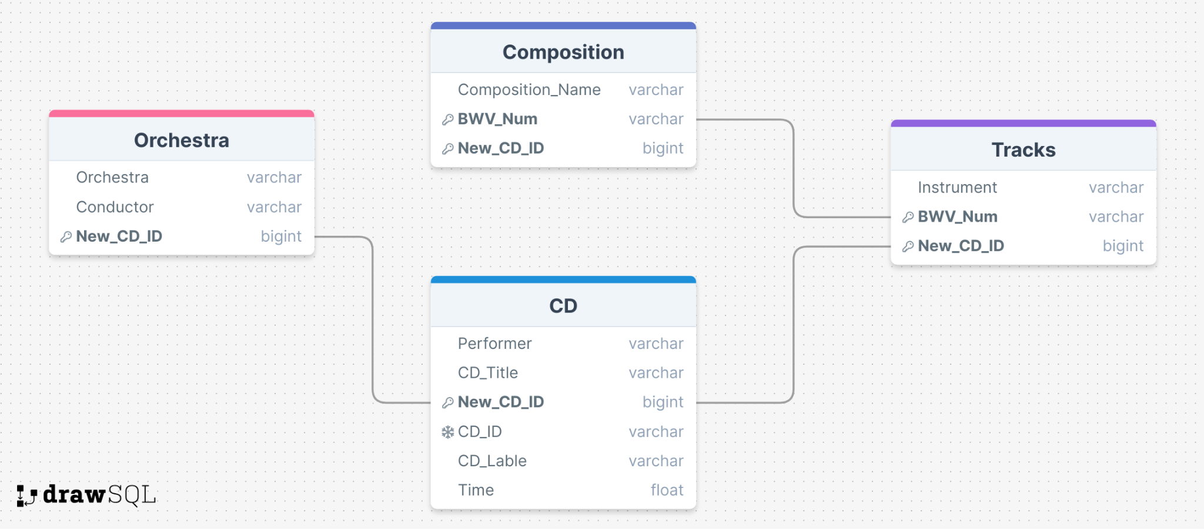

Queries

1. SELECT Composition.Composition_Name FROM Composition

JOIN Tracks ON Tracks.BWV_Num = Composition.BWV_Num and Tracks.New_CD_ID = Composition.New_CD_ID

WHERE Instrument = "Harpsichord"

1. SELECT Composition_Name FROM Composition WHERE Composition_Name LIKE '%Concerto%'
2. SELECT CD.CD_Title, CD.Performer FROM CD

JOIN Tracks

WHERE Tracks.New_CD_ID = CD.NEW_CD_ID

AND Tracks.BWV_Num = "BWV 780"

1. Select Composition.Composition_Name FROM Composition

JOIN CD ON CD.New_CD_ID = Composition.New_CD_ID

JOIN Tracks ON Tracks.BWV_Num = Composition.BWV_Num and Tracks.New_CD_ID = Composition.New_CD_ID

WHERE CD.Performer = 'Glenn Gould'

1. SELECT c.Composition_Name, t1.BWV_Num, COUNT(DISTINCT t2.Instrument) AS Num_Different_Instruments

FROM Composition AS c

INNER JOIN Tracks AS t1 ON c.BWV_Num = t1.BWV_Num

LEFT JOIN Tracks AS t2 ON t1.BWV_Num = t2.BWV_Num

GROUP BY c.Composition_Name, t1.BWV_Num

HAVING COUNT(DISTINCT t2.Instrument) > 1 OR COUNT(DISTINCT t2.Instrument) = 1;

1. SELECT Composition_Name FROM Composition

WHERE Composition_Name LIKE '%F# Minor'